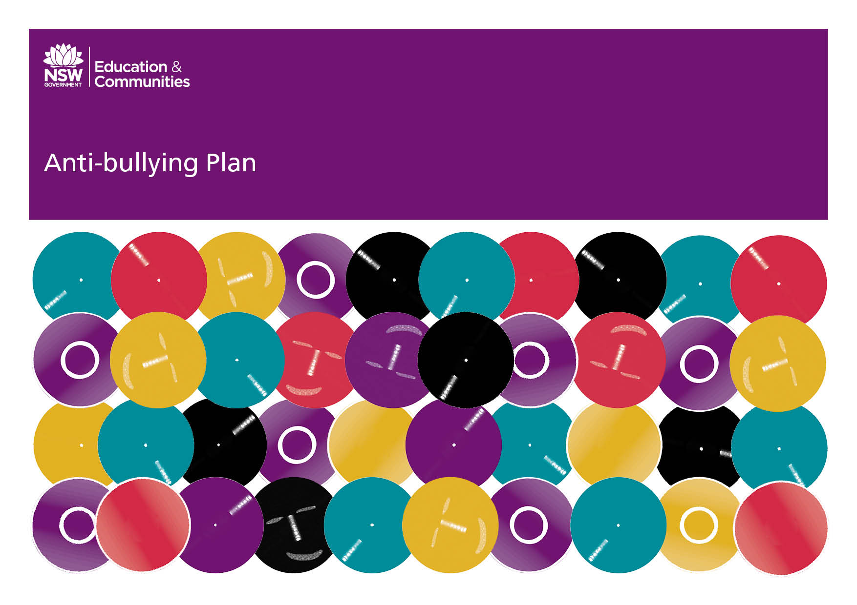
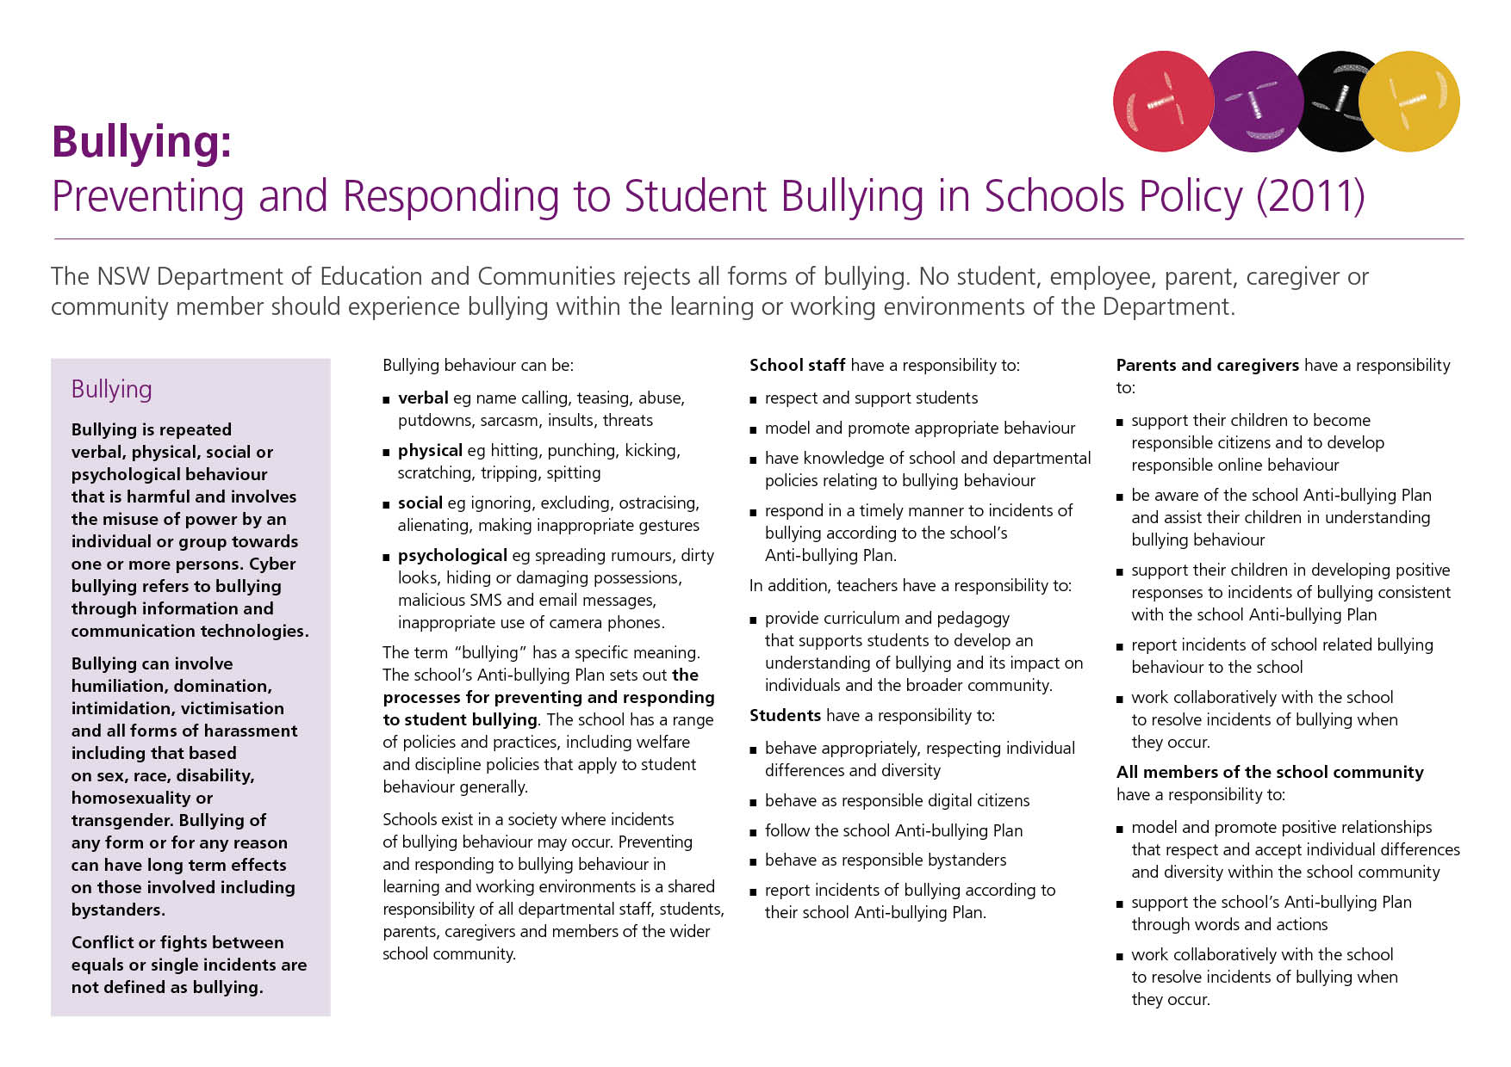
Our School Anti-Bullying Plan
Sandy Beach Public School

Our School Anti-Bullying Plan
This plan outlines the processes for preventing and responding to student bullying in our school and reflects the Bullying: Preventing and Responding to Student Bullying in Schools Policy of the New South Wales Department of Education and Communities.
This plan was initially developed in collaboration with the Sandy Beach Public Student Welfare team, drafted by the school executive and then the parents of Sandy Beach Public School were invited to make comment on the plan in draft-form over the course of two weeks (obtaining copies of the draft plan from our school website or in hard copy form from the school office).
Once the draft period was completed, the proposed plan was presented at a school P&C meeting during Term 1, 2012. The plan will be implemented at the beginning of Term 2, 2012 and will be formally reviewed at least once every three years.

Statement of purpose
An educational environment that protects, prevents and responds to bullying ensures that our students are successful learners, confident and creative individuals and active and informed citizens, consistent with the Melbourne Declaration of Goals for Young Australians (2008).

Our school is built on the Values for Australian Schooling:

CARE AND COMPASSION
DOING YOUR BEST
A FAIR GO FOR EVERYONE
FREEDOM, HONESTY AND TRUSTWORTHINESS
INTEGRITY
RESPECT
RESPONSIBILITY
UNDERSTANDING, TOLERANCE AND INCLUSION

These values contribute to a safe yet challenging learning environment where bullying is not tolerated. Students attend school to participate in quality education that will help them to become self directed, lifelong learners who can create a positive future for themselves and the wider community.
At SBPS we will-
- Foster a culture where students feel safe to report incidents of bullying to themselves or others; and
- Ensure that all bullying incidents are dealt with according to this anti-bullying plan.

Outcomes:
As a result of implementing the 2012 Anti-bullying Plan, we will
- ensure that a safe and happy learning environment continues to develop at SBPS;
- reduce the incidence of bullying at our school;
- increase the number of students who are capable of reporting bullying behavior;
- collect data on bullying more accurately and using RISC software to record incidences;
- help students, parents and staff to understand the definition, types and changing nature of bullying in our school and society;
- ensure that all staff (teaching and support staff) understand and apply the procedures set out in this Anti-bullying Plan;
- ensure that students are explicitly taught and begin using strategies outlined in this Anti-bullying Plan; and that
Protection
What is Bullying?
Bullying is defined as intentional, repeated behaviour by an individual or group of individuals that causes distress, hurt or undue pressure. Bullying involves the abuse of power in relationships and can involve all forms of harassment (including sex, race, disability, homosexuality or transgender), humiliation, domination and intimidation of others.
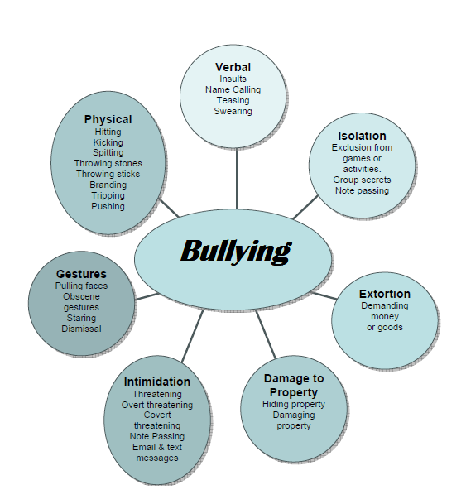

Any inappropriate behaviour that gets in the way of teaching and learning at the school and interferes with the wellbeing of students cannot be accepted, including cyberbullying.
Students, teachers, parents, caregivers and members of the wider school community have a shared responsibility to create a safe and happy environment, free from all forms of bullying.

Students, teachers, parents, caregivers and members of the wider school community can expect
- that students will be safe at school, free from fear of bullying, harassment and intimidation
- to be involved in the collaborative development of the school Anti-bullying Plan
- to know what is expected of them and others in relation to the Anti-bullying Plan
- that all students will be provided with appropriate support when bullying occurs.

Students, teachers, parents, caregivers and members of the wider school community have a responsibility to
- promote positive relationships that respect and accept individual differences and diversity within the whole school community
- contribute to the development of this Anti-bullying Plan and support it through words and actions
- actively work together to resolve incidents of bullying behaviour when they occur.

Strategies We Will Use to Deal With Bullying
At Sandy Beach Public School we will:
- talk openly about bullying - what it is, how it affects us and what we can do about it.
- teach our students the skills they need to recognise, report and empower them to deal with bullying behaviour and provide them with opportunities to practise these skills through teaching and learning programs within their classes.
- respond to substantiated instances of bullying through our school welfare and discipline policy and all relevant Department of Education and Communities (DEC) policy and procedures.
Our students have a responsibility to
- advise teachers of any bullying or teasing directed at themselves or others
- behave appropriately, respecting individual differences and diversity
- follow the school rules
- behave as responsible bystanders
- behave as responsible citizens
- respond to incidences of bullying according this plan.

Parents and caregivers have a responsibility to
  - support their children to become responsible citizens and to develop responsible on-line behaviour
  - be aware of the school Anti-bullying Plan and assist their children in understanding bullying behaviour
  - support their children in developing positive responses to incidents of bullying consistent with this Anti-bullying Plan
  - report incidents of school related bullying behaviour to the school
  - work collaboratively with the school to resolve incidents of bullying when they occur
  - support all students of the school to deal effectively with bullying
  - support activities and initiatives of the school to minimise bullying and teasing.
Our teachers have a responsibility to
- behave appropriately, respecting individual differences and diversity
- follow the school Anti-bullying Plan
- behave as responsible bystanders
- report incidents of bullying according to their school Anti-bullying Plan
- record details of bullying and teasing on RISC.

Our principal is responsible for:
- implementing the policy within the school
- submitting a copy of the school's Anti-bullying Plan to the school education director whenever it is reviewed
- reporting annually to their school community on the effectiveness of our school's Anti-bullying Plan.

Our school has a responsibility to
- inform the students, parents, caregivers and the community about the School’s Welfare & Discipline Policy and Anti-bullying Plan
- review the plan annually or as the need arises
- provide reports to the school community on discipline, suspension and expulsion trends through the annual school report.
- provide students with strategies to respond positively to incidents of bullying behaviour, including responsibilities as bystanders or observers
- provide parents, caregivers and students with clear information on strategies that promote appropriate behaviour, and the consequences for inappropriate behaviour
- communicate to parents and caregivers that they have an important role to play in resolving incidents of bullying behaviour involving their children
- follow up complaints of bullying, harassment, intimidation and victimisation.
Prevention
At our school, the staff in every stage, teach lessons through their personal development program. Lessons will explicitly outline anti-bullying strategies.
Complimentary programs include ‘Life Education-Healthy Harold’, ‘No-Go-Tell’, ‘Rock & Water’ and cyber-bullying programs in computer sessions.
All of these programs, combined with the anti-bullying theme embedded in our annual peer support program, educate students on ways that they can protect themselves and others from bullying behaviours.
Not only do our programs educate victims of bullying behaviours, they seek to educate students on the ‘responsible bystander’ concept. Teachers educate students on what they can do to help possible victims of Bullying and on their responsibilities if they witness bullying behavior at Sandy Beach Public School.

Early Intervention
Those students who are at risk of being victims of bullying type behaviours are encouraged to report directly to teachers on duty, classroom teachers or a member of staff that they themselves have nominated.
Parents are encouraged to notify the school of possible bullying incidents and similarly they will be notified of any school-based incidents.
Reinforcing the message that “it is ok to report bullying” is key to early intervention.
Students who are at risk of being victims bullying must feel comfortable that it is not ‘dobbing’ when reporting threats or intimidation.

Any early intervention strategies will be communicated to staff and arrangements are to be followed up with a consistent approach.

Response
As outlined in our Student Welfare Policy, one-off incidents of inappropriate behaviour are dealt with by the class or playground teachers as they arise. If the inappropriate behaviours are repeated, whether they are verbal, physical, social or psychological, then other strategies come into action.
At the outset, all students are consistently reminded that they have the right to come to school and feel happy and confident in their learning and play, free from bullying and harassment. No-one has the right to make another person feel worried or uncomfortable. If someone is making a student feel like this, then they must tell someone about it. Telling someone about bullying behaviour is not "dobbing" it is merely asserting their right to feel safe and happy while at school and while coming and going to school.

Strategies When a Bullying Incident is Observed or Reported:
- The incident is investigated by the teacher to whom it has been reported;
- The teacher determines whether or not the incident is bullying, according to the agreed definition;
- If it is not bullying the incident is dealt with by the teacher in accordance with the Student Welfare and Discipline Policy;
If bullying is verified, the incident is dealt with using the following strategies:
1. Interview bullies. This is done alone, one by one, starting with the student seen as the bullying group leader. This is a non-adversarial interview designed to emphasise the concern of the person who is being hurt or elicit some empathy and to come to some agreement as to what the person might do to help the victim. During the meeting the teacher remains calm, empathetic, never angry or indignant and respect is shown for the bully as a person. A record of this event is recorded into the school’s RISC program.
2. Interview with the victim. This is done in a supportive manner and the aim is to explore ways in which the victim can behave to minimise the chances of the bullying being repeated. This may involve the victim being shown assertive behaviour or reducing behaviour which may be provoking the bullies.
3. Follow-up with bullies and victims. It is essential that daily follow-up takes place. This involves asking the bullies individually how they have followed through what they agreed to do to help the victim, and asking the victim how they are progressing and whether or not there have been any further incidents. The follow-up is initially carried out daily, then tapered off if all is going well.
4. If the bullying behaviour does not stop as a result of this intervention, then the usual sanctions of the Student Welfare and Discipline Policy will be implemented. There will be a need to keep working with the victim at this time to support them and make sure that they continue to problem solve to try to make sure that there is not something else they can do to prevent the bullying from re-occurring. This may have to be carried out by a member of the school executive, depending when the bullying incidents come to light. Subsequent incidences of bullying are recorded into the schools RISC program.
Where the bullying does not stop, the parents of the bully(ies) and any victims must be contacted and involved in resolving the matter.
Incidents of significant bullying will be communicated to staff and any management procedures are then followed up in a systematic and consistent way across the whole school.
Communicating Bullying Plan and Procedures
It is important that at least once each year, the whole school community is reminded of the school's Anti-Bullying Policy. This will be done through the school weekly newsletter and on our school website It is important to re-emphasize at this time that it is all right for students to tell if they are being bullied.
Professional learning regarding these procedures needs to be done every two years or when there is a significant change in staff in any one year. At this time an evaluation of the Anti-Bullying Plan will take place. At these times it may be necessary to survey the students, staff and parents to see how widespread the bullying is at our school.
Principal’s comment

This plan is the result of a considered and collaborative approach to anti-bullying in our school community. The plan sits within the framework of our student welfare and discipline policy. It is a tangible record of our commitment to the safety and welfare of every student in the school and our partnership with parents and caregivers.

Plan Development Team:

Ray Rincheval - Principal
Sam Murgatroyd - Assistant Principal & Student Welfare Team Leader
Fiona Robinson - Class teacher & School Welfare Team Member
Sue Acason - Class teacher & School Welfare Team Member
Diane Della – P&C President and parent representative

Additional Information
Additional information, resources and support relating to effective anti-bullying strategies can be found at:
www.bullyingnoway.com.au
www.kidshelpline.com.au
www.reachout.com.au
Bullying among young people: A guide for parents.
To get a copy, call 1800 708 777.

School contact information
Sandy Beach Public School
19 Saye Close, Sandy Beach NSW 2456
Ph: (02) 6656 1777 Fax: (02) 6656 1624
sandybeach-p.school@det.nsw.edu.au

